Development Environment

# Install JDK 8

Set JAVA_HOME:

1. Right click My Computer and select Properties.
2. On the Advanced tab, select Environment Variables, and then edit JAVA_HOME to point to where the JDK software is located, for example, C:\Program Files\Java\jdk1.8.0_144

Verify that

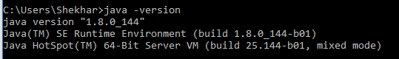

# Project Build Tool

Gradle, Maven

## Maven

Download maven from <https://maven.apache.org/download.cgi>

INstallation guide <https://maven.apache.org/install.html>

# IDE

IntelliJ IDEA, STS